Designing basic model and E-R Diagrams

E-R diagrams represent the schemas or the overall organization of the system. In this section, we’ll apply the concepts of E-R modeling to our “Library Management System” and draw its E-R diagram.
In order to begin constructing the basic model, the modeler must analyze the information gathered during the requirement analysis for the purpose of: and
- classifying data objects as either entities or attributes,
- identifying and defining relationships between entities,
- naming and defining identified entities, attributes, and relationships,
- documenting this information in the data document.
- Finally draw its ER diagram.
To accomplish these goals the modeler must analyze narratives from users, notes from meeting, policy and procedure documents, and, if lucky, design documents from the current information system.

E-R diagrams constructs
In E-R diagrams, entity types are represented by squares. See the table below. Relationship types are shown in diamond shaped boxes attached to the participating entity types with straight lines. Attributes are shown in ovals, and each attribute is attached to its entity type or relationship type by a straight line. Multivalued attributes are shown in double ovals. Key attributes have their names underlined. Derived attributes are shown in dotted ovals.
Weak entity types are distinguished by being placed in double rectangles and by having their identifying relationship placed in double diamonds.
Attaching a 1, M, or N on each participating edge specifies cardinality ratio of each binary relationship type. The participation constraint is specified by a single line for partial participation and by double lines for total participation. The participation constraints specify whether the existence of an entity depends on its being related to another entity via the relationship type. If every entity of an entity set is related to some other entity set via a relationship type, then the participation of the first entity type is total. If only few member of an entity type is related to some entity type via a relationship type, the participation is partial.
 | ENTITY TYPE
 | WEAK ENTITY TYPE
 | RELATIONSHIP TYPE
 | ATTRIBUTE
 | KEY ATTRIBUTE
 | MULTIVALUED ATTRIBUTE
 | DERIVED ATTRIBUTE
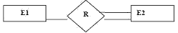 | TOTAL PARTICIPATION OF E2 IN R
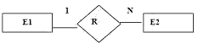 | Cardinality Ratio 1:N FOR E1:E2 IN R
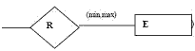 | Structural Constraint(Min,Max) On Participation Of E In R

Naming Data Objects
The names should have the following properties:
- unique,
- have meaning to the end-user.
- contain the minimum number of words needed to uniquely and accurately describe the object.
For entities and attributes, names are singular nouns while relationship names are typically verbs.

E-R Diagram for library management system
In the library Management system, the following entities and attributes can be identified.
- Book -the set all the books in the library. Each book has a Book-id, Title, Author, Price, and Available (y or n) as its attributes.
- Member-the set all the library members. The member is described by the attributes Member_id, Name, Street, City, Zip_code, Mem_type, Mem_date (date of membership), Expiry_date.
- Publisher-the set of all the publishers of the books. Attributes of this entity are Pub_id, Name, Street, City, and Zip_code.
- Supplier-the set of all the Suppliers of the books. Attributes of this entity are Sup_id, Name, Street, City, and Zip_code.
Assumptions: a publisher publishes a book. Supplier supplies book to library. Members borrow the book (only issue).
Return of book is not taken into account
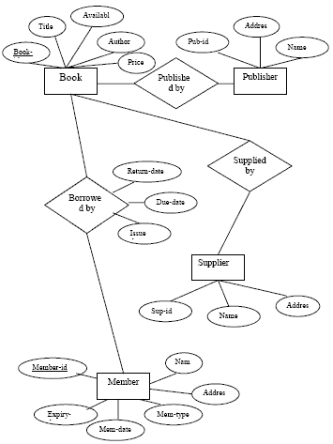
Fig. 7.13 E-R Diagram of Library Management System.

